**TALENTED 16 YEAR OLD HITTING THE RIGHT NOTES**

**Easter Seals UCP**

**Posted byEaster Seals UCP2/4/14 in**[**Our Scene**](http://nc.eastersealsucp.com/news-blog/Hitting-the-Right-Notes/#our-scene)

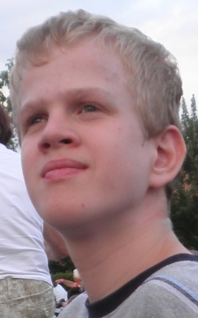*Matthew Andreas Wulf*

Matthew Andreas Wulf is quite an amazing 16-year old. While he may live with a a neurological genetic disorder that causes him to have peripheral blindness, hearing loss, liver failure, low muscle tone and the inability to orient himself in space, he is certainly not defined by it.

The Weddington, NC teenager is a wonderful example of the Easter Seals UCP motto of living a life without limits. He’s a talented poet and music composer with goals of his music one day being played by a professional symphony orchestra. He’s also recently discovered a passion for cooking and plans to compile a cookbook for others that live with his genetic disorder.

For the past three years, Easter Seals UCP has been providing community support services, including in-home support, personal care and respite to Matthew and his family. The support that Matthew and his family receive allow him the opportunity to further his development, learn daily living skills and gain independence. As part of the support from Easter Seals UCP, Matthew is developing life goals, which he works on each week. Furthering his music writing and learning to cook are just two of his many goals.

Matthews’s passion for music composition stemmed from a 5th grade spelling bee where he was asked to spell and say the word “sonata” in a sentence. He declared that he wanted to write a sonata and expressed to his mother his seriousness to do so. While Matthew doesn’t have the dexterity to play the piano himself, his mom signed him up for piano lessons to learn the notes and sounds.

At the end of his piano lessons, his piano teacher gave him a digital music composition program and Matthew went to work on composing his first sonata encompassing the piano and flute instruments. He went on to compose seven more music compositions and he’s currently working on a symphony piece called Family, which he one day hopes will be played by a professional symphony orchestra.

Not long ago, Matthew had the opportunity to have his music played at a Music Arts Society Program for American composers in Philadelphia where he was able to hear for the first time a professional pianist play his song The Song of My Music – one of his family’s favorite songs.

“Matthew expresses himself through his poetry and music,” said his mother Joyce Wulf. “The words and music pore out of him and as an audience you can feel his emotions and passion. We’re so proud of him and love seeing his dreams come true.”

In addition to music composition, Matthew is also learning to cook. A task made even more difficult due to his restrictive diet. Not only has he discovered a love for cooking, but he’s creating some really outstanding recipes that he wants to compile for a cookbook for others living with his genetic disorder.

The sky’s the limit for Matthew and Easter Seals UCP is proud to be on this journey with him.