Two Studies, Two Products, Two Results

“**Clinical management and treatment**”

“Because no curative therapy for patients with a ZSD exists, intervention is supportive and based on symptoms. Past- and current supportive therapeutic options are summarized in Table 4.

Docosahexaenoic acid Docosahexaenoic acid (DHA; C22:6ω3) is a long-chain polyunsaturated fatty acid important for retinal and brain function [40, 41]. Tetracosahexaenoic acid (C24:6ω3) undergoes one cycle of peroxisomal beta-oxidation to be converted to DHA [4], leading to reduced levels of DHA when peroxisomes are absent. Because ZSD patients often have low levels of DHA in membranes of erythrocytes, supplementation of DHA was suggested to be a possible therapy. Although some studies have claimed a beneficial effect of DHA supplementation [42, 43], a randomized double-blind placebo controlled trial showed that DHA treatment leads to increased DHA levels in plasma, but no improvement of visual function and growth could be observed [44].” [1]

42. Martínez M, Vázquez E, García-Silva MT, Manzanares J, Bertran JM, Castelló F, et al. Therapeutic effects of docosahexaenoic acid ethyl ester in patients with generalized peroxisomal disorders. Am J Clin Nutr. 2000;71 Suppl 1:376S–85S.

43. Noguer MT, Martinez M. Visual follow-up in peroxisomal-disorder patients treated with docosahexaenoic Acid ethyl ester. Invest Ophthalmol Vis Sci. 2010;51:2277–85.

44. Paker M, Sunness JS, Brereton NH, Speedie LJ, Albanna L, Dharmaraj S, et al. Docosahexaenoic acid therapy in peroxisomal diseases: results of a doubleblind, randomized trial. Neurology. 2010;75:826–30.

Treating physicians easily reference treatment options of Zellweger Spectrum Disorders on line. Why is there a discrepancy between the two studies referenced above? Investigation into the products of these two studies, in the work of Manuel Martinez, MD and clinical trial of M. Paker, et. al., are shown in the table below. The two studies each used a different product from different sources, processed differently, and yielding two different results, one helpful, and the other with no benefit. These two studies were very dissimilar, and therefore, not comparable, even if one was a double blind, randomized study. In basic science, to be comparable, the products should at least be the same.

|  |  |  |
| --- | --- | --- |
|  | Martinez | Paker, et al. |
| Manufacturer  and product | Bizen Chemical, DHA-EE | Martek Biosciences Corporation, Formulaid |
| Product source | Small-body, cold-water fish | Crypthecodinium cohni or Schizochytrium sp. Algae2 |
| DHA Molecular form | Docosahexaenoic acid-ethyl ester | Docosahexaenoic acid-triglyceride |
| Percentage of DHA | 97% | 47% DHA; 46% AA |
| Processing | Patented low temperature extraction | fermentation, patented hexane extraction |
| Dose | 200 mg/d | 100 mg/kg/d |
| Added ingredients | Olive oil, gelatin | Gelatin, algal oil, fungal oil (ARA), high oleic sunflower oil, cornstarch, sucrose, water, ascorbyl palmitate, natural vitamin E (missed natural tocopherals, and preservatives (sodium benzoate, potassium, sorbate, methyl paraben, propyl paraben), natural and artificial flavors |
| delivery | Frozen unit dose by mouth | Microencapsulated powder by mouth |
| Anti-inflammatory properties | Naturally high in anti-inflammatory lipid mediators | None noted |
| Dietary recommendations | Normal diet for age level;  prepare food fresh | Low phytanic acid |
| Study type | Non-placebo, non-blind | Randomized, double-blind placebo-controlled |
| Results | Improvement in lowering VLCFA’s, liver enzyme function; myelination, muscle tone, vision, reflexes, socialization, and steatorrhea correction | No difference between treated and untreated groups in biochemical function, electroretinogram, or growth |

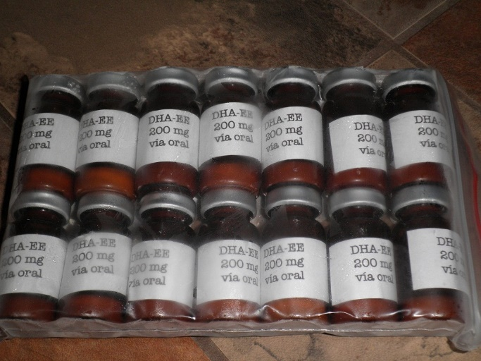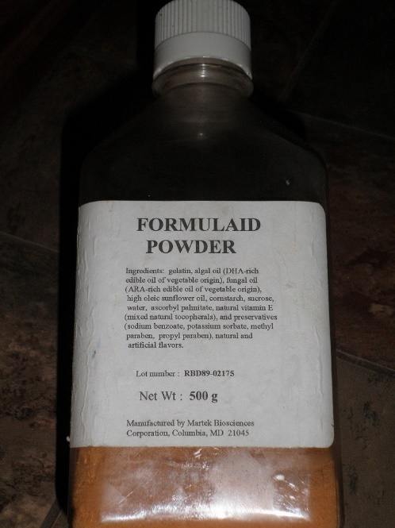

**What is in DHA Algal Oil from Schizochytrium species used by the Paker, et al. study?**

“DHA Algal Oil from Schizochytrium species contains DHA (approx. 35%), 30 palmitic acid (approx. 24%), docosapentaenoic acid (approx. 13.5%), myristic acid (approx. 10%), and 31 eicosapentaenoic acid (EPA) (approx. 3%) (FDA 2004b).”

<https://www.ams.usda.gov/sites/default/files/media/DHA%20Algal%20Oil%20TR.pdf>

**Are there concerns with a genetically modified algal oil DHA processed with a known neurotoxin, hexane (“at a detection limit of <0.3 ppm”[2])?** See link at end or read quote below.

**“GM but Recommended for Approval for Organic List?**

Martek's DHA and ARA oils have been recommended by the [USDA](https://www.sourcewatch.org/index.php?title=USDA) [National Organic Standards Board](https://www.sourcewatch.org/index.php?title=National_Organic_Standards_Board) (NOSB) for addition to the "National List of Allowed and Prohibited Substances."[[13]](https://www.sourcewatch.org/index.php/Martek_Biosciences#cite_note-13)[[14]](https://www.sourcewatch.org/index.php/Martek_Biosciences#cite_note-14) However, these additives are produced using methods of [genetic modification](https://www.sourcewatch.org/index.php?title=Genetically_modified) such as "microencapsulation,"[[15]](https://www.sourcewatch.org/index.php/Martek_Biosciences#cite_note-15) which is expressly banned by the USDA [National Organic Program](https://www.sourcewatch.org/index.php?title=National_Organic_Program) definition of "Excluded methods" (Title 7, § 205.2 of the Electronic Code of Federal Regulations).[[16]](https://www.sourcewatch.org/index.php/Martek_Biosciences#cite_note-16)

**Previous USDA Scandal**

In 2006, according to the *Washington Post*, FDA staff members determined that the companies producing organic baby formula were not permitted to add DHA and ARA to their formulas, both of which are Martek products. However, the decision was overruled by deputy [U.S. Department of Agriculture](https://www.sourcewatch.org/index.php?title=U.S._Department_of_Agriculture) (USDA) [National Organic Program](https://www.sourcewatch.org/index.php?title=National_Organic_Program) (NOP) administrator Barbara Robinson. The move was highly controversial. DHA and ARA were not approved synthetics by the [National Organic Standards Board](https://www.sourcewatch.org/index.php?title=National_Organic_Standards_Board) (NOSB) because a potential neurotoxin called hexane is used in the production process for the fatty acids.[[17]](https://www.sourcewatch.org/index.php/Martek_Biosciences#cite_note-WaPo-17)

**FDA Concerns**

The [U.S. Food and Drug Administration](https://www.sourcewatch.org/index.php?title=U.S._Food_and_Drug_Administration) (FDA) conditionally approved Martek's DHA and ARA oil additives as "generally recognized as safe" (GRAS) in 2001. The FDA's letter to Martek accompanying its decision expressed the following concerns:[[18]](https://www.sourcewatch.org/index.php/Martek_Biosciences#cite_note-FDAletter-18)

"[S]ome studies have reported unexpected deaths among infants who consumed formula supplemented with LCPUFAs. These unexpected deaths were attributed to Sudden Infant Death Syndrome (SIDS), sepsis or necrotizing enterocolitis. Also, some studies have reported adverse events and other morbidities including diarrhea, flatulence, jaundice, and apnea in infants fed LCPUFAs."

The decision notes that the approval of the ingredient does not negate the responsibility of infant formula manufacturers that include the additives to monitor and submit reports on adverse infant reactions to the FDA.[[18]](https://www.sourcewatch.org/index.php/Martek_Biosciences#cite_note-FDAletter-18)

However, none of the companies selling formula and other products containing the DHA and ARA oils have monitored reactions to these products and reported back to the FDA, according to the 2009 results of a FOIA request made by Cornucopia. The 98 adverse reactions were self-reported.[[19]](https://www.sourcewatch.org/index.php/Martek_Biosciences#cite_note-19)

Martek's additives are now added to more than 99 percent of American infant formulas, according to the company, as well as baby foods, supplements, milk and other food products.[[20]](https://www.sourcewatch.org/index.php/Martek_Biosciences#cite_note-20) This includes 90 percent of formulas certified as organic by the [U.S. Department of Agriculture](https://www.sourcewatch.org/index.php?title=U.S._Department_of_Agriculture) (USDA), according to the *Washington Post*.[[17]](https://www.sourcewatch.org/index.php/Martek_Biosciences#cite_note-WaPo-17)”

Quote from: <https://www.sourcewatch.org/index.php/Martek_Biosciences#cite_note-15>

See: <https://www.cornucopia.org/dha-safety-concerns/?gclid=CJzh_cv8jcECFZDm7AodfVgAFg>

**For a list of foods containing Martek BioScience DHA**, see the below link.

<http://drkaayladaniel.com/the-oiling-of-america-adding-dha-sda-and-other-gmo-ingredients-to-health-foods/>

[**http://www.cornucopia.org/what-are-marteks-dha-and-ara-oils/**](http://www.cornucopia.org/dha-guide/)

**For the benefits of using DHA from fish oil for Zellweger Spectrum Disorders see link below:**

**Modulation of inflammation in brain: a matter of fat**

Akhlaq A. Farooqui , Lloyd A. Horrocks, Tahira Farooqui

Journal of Neurochemistry, January 25, 2007

<https://doi.org/10.1111/j.1471-4159.2006.04371.x>

A brief list from Modulation of Inflammation in Brain: A Matter of Fat

* DHA binds to endocannabinoid receptors lowering the severity of inflammation, increasing vasodilatory action on cerebral microcirculation, and modulation of immune cells (p. 10).
* The richest source of DHA is fish oil. Consumption of DHA has numerous beneficial effects on the health of the human brain due to its physicochemical properties of neural membranes, but also of its modulation of neurotransmission (p. 11).

From table 2 (p. 11): Role of DHA

* Modulation of neurotransmitter release
* Modulation of gene expression
* Modulation of membrane enzymes, ion channels and receptors
* Modulation of learning and memory processes
* Modulation of immunity and inflammation
* Modulation of blood-brain barrier
* Modulation of apoptosis
* DHA exerts neuroprotective effects, inhibiting neuroinflammation and oxidative stress (p. 14)
* In brain tissue DHA-derived metabolites promote resolution and protect neural cells from neurodegeneration (p. 14)
* DHA generates resolvins and docosatrienes, preventing brain damage (p.14)
* DHA restores signal transduction processes by protecting neurons from harmful effects of neuroinflammation (p. 14)
* DHA increases seizure threshold, lowering the inflammatory mediators that are increased in patients with epilepsy (p. 15)
* DHA has anti-cancer properties (p. 16)

Other studies show DHA fish oil also induces peroxisome proliferation, is critical to immune function, prevention of protein misfolding and mitochondrial dysfunction, beneficial mood modulation, an intervention in non-alcoholic fatty liver disease, etc.

For more information on DHA see: <https://www.mawulf.com/research/dha-ee-research/>

**Conclusion**

It takes time to analyze clinical trials and the products they use in order to draw truthful conclusions. Understandably, time is a short commodity for most professionals in health care. But not taking the time to investigate the facts of these two clinical trials may deprive children of benefits otherwise lost. Studies on DHA benefits are two numerous to count, yet can one study using a DHA product from genetically modified organisms, processed with a known neurotoxin, documented to cause SIDS and necrotizing enterocolitis in infants, turn the heads of doctors to believe other DHA studies using fish oil hold no value?

1. **Zellweger spectrum disorders: clinical overview and management approach**

   Femke C. C. Klouwer†, Kevin Berendse†, Sacha Ferdinandusse, Ronald J. A. Wanders, Marc Engelen and Bwee Tien Poll-The

   *Orphanet Journal of Rare Diseases*2015**10**:151

   <https://ojrd.biomedcentral.com/articles/10.1186/s13023-015-0368-9>
2. <https://www.ams.usda.gov/sites/default/files/media/DHA%20Algal%20Oil%20TR.pdf> p. 7 of 26